Journal #2

Louis Harshman – WaveSpeak

Goals:

1. Get PCB design started and ready for integration with cad model.
2. Research software for switch backplane microcontroller.
3. Have PCB ready for manufacturing by Friday!
4. Get 3D STL models finalized for Mr. Combs to print.
5. Review overall product and ensure integration will work.
6. Purchase another inland pro-micro due to unforeseen... I broke the pro-micro by ripping the USB port off.
7. Fix printing issues
8. ORDER PCBs
9. Finish getting switch handler program finished.

Reflection on goals and Timeline:

I’ve yet to order the PCB due to design changes but I plan on ordering them on the 20th of December. I am behind on the timeline, but I am making a great amount of progress, so I am not worried at all. I will need to adjust the timeline due to delays in production. I’ll probably drop 2-3 weeks.

Accomplishments:

I got the PCB backplate and back case finished which I am proud of. The 3d print came out really accurate, and it fits my display!

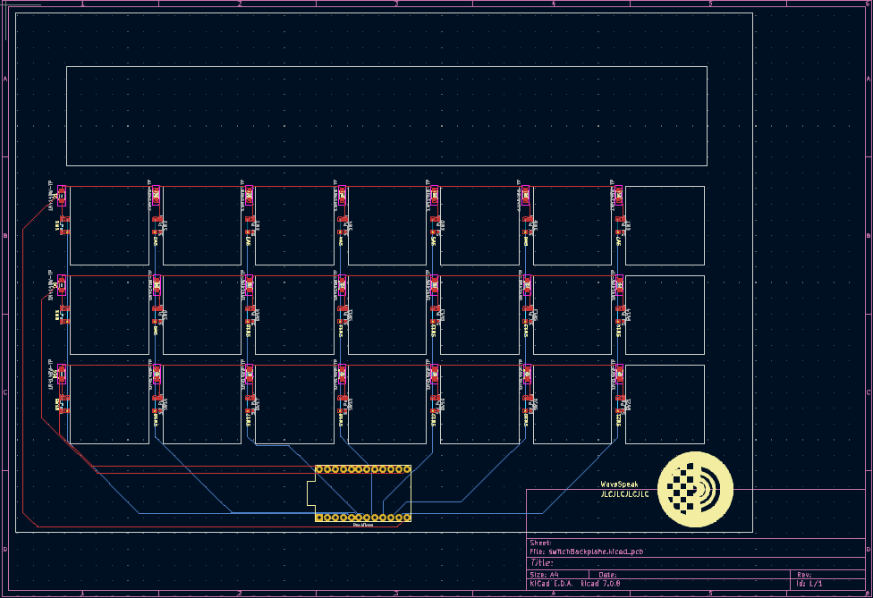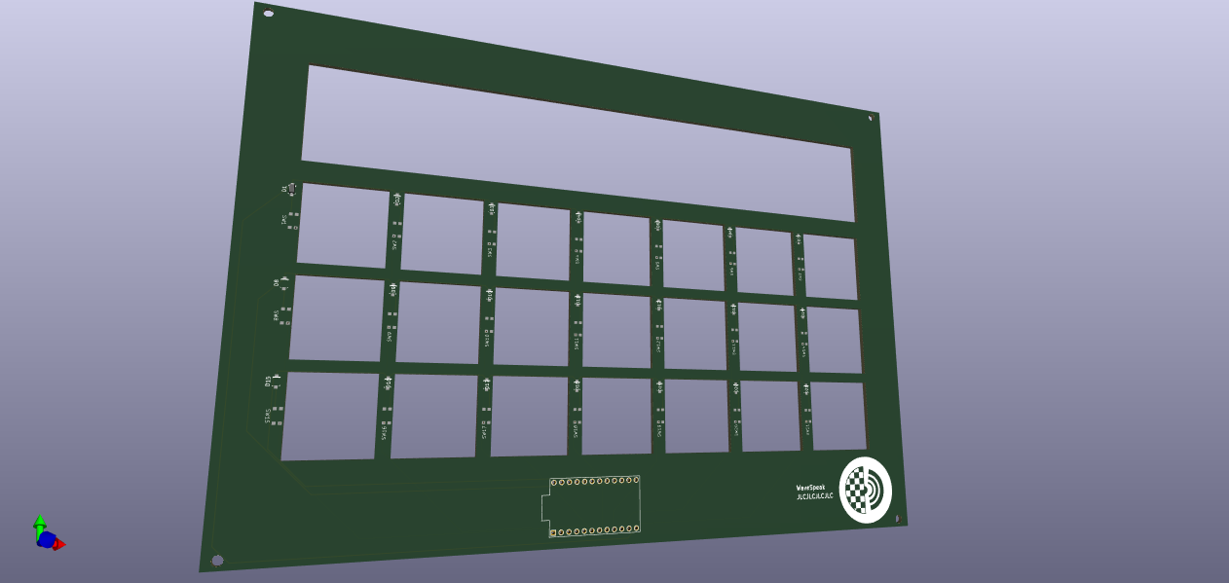



The tablet is now running FullPageOS which is a useful kiosk type of OS that serves static HTML websites.

My Research and What I learned:

I focused my research mostly on PCB design and standards. I also learned more about good OSes for the raspberry pi. Here are all the PCB design related videos I’ve watched to learn how to make the KiCad schematics.

<https://youtube.com/playlist?list=PL5JVfKgqlUh4Db6WbDxrnOfeUj1j-ZTqX&si=muedXBRYDA-DDMau>

I have learned the following topic general and specific topics.

* Electrical engineering
  + Diodes
  + Key matrixes
  + Micro Controllers
  + PCB Design and manufacture
* Programming/Software architecture
  + Arduino programming
  + C++ Programming
  + Web Development
  + Linux Embedded development
* Hardware design
  + 3D printing tolerance
  + Slicing design